Media Consent Form | 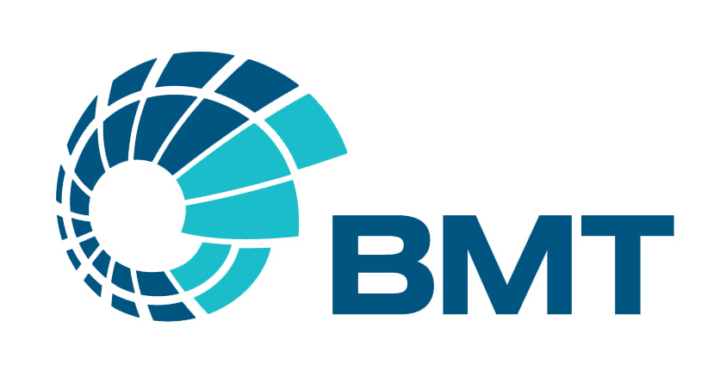

BMT is committed to processing information in accordance with the General Data Protection Regulation (GDPR). The personal data collected on this form will be held securely up to 12 months on servers at BMT office locations and will only be used for administrative purposes.

Project Title | BMT STEM Challenge
How your contribution will be used by us
You have the right to be informed of how we will use the image/recording you have made.
The main purpose of creating the video:
BMT are launching a number of STEM challenges and are asking participants to send a photograph or video as part of the competition submission.

Sharing photos and video is one of the best ways to inspire others to get involved in STEM activities. Therefore, entries may be featured on BMT marketing (including BMT website, social media pages such as LinkedIn), to encourage others to get involved.

TO BE COMPLETED BY PARENT / CARER / LEGAL GUARDIAN
(If under 16 signatures of parent/carer /legal guardian required)
I have read and a accept the terms and conditions written in the copyright and permissions section of BMT’s STEM Activity pack. |  | ☐
I authorise BMT to utilise my child’s photograph/video for the purposes described above. |  | ☐
I authorise BMT to utilise my child’s likeness, image and/or voice, for the purposes described above. |  | ☐
Name of person appearing
Name of parent / carer / legal guardian

Phone no.
Signature
Date

PLEASE COMPLETE AND RETURN THE SECTION ABOVE. THE SECTION BELOW SHOULD BE RETAINED FOR YOUR REFERENCE.

TO BE RETAINED BY PARENT / CARER / LEGAL GUARDIAN

Project Title | BMT STEM Challenge
Date

You have the right to request to see a copy of the information we (BMT) hold about your child and to request corrections or deletions of the information that is no longer required. You can ask BMT to stop using images of your child at any time, in which case it will not be used in future materials but may continue to appear in material already in circulation. You have the right to lodge a complaint against BMT regarding data protection issues with the Information Commissioner’s Office (https://ico.org.uk/concerns/).

Web: https://www.bmt.org/ |  | Email: STEMChallenge@bmtglobal.com

